School Performances

HotHouse offers weekday matinee performances of our productions so students can experience our work. Each of these matinees is followed by a Q&A session with the cast.

Tickets to the weekday matinees are $18 per student with one free teacher ticket per 10 students. For the greatest flexibility to attend a number of shows in the year, we recommend the Flexi 100 Pack, giving you 100 tickets to use throughout the year for a great price.

To express your interest in bring a school’s group to HotHouse in 2016, please fill in this form and email to education@hothousetheatre.com.au .

2016 Performances

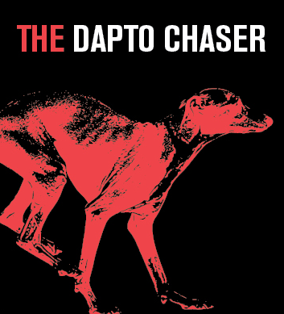
Thursday 17 March, 11am
Running time: Approximately 95 minutes, no interval
Followed by Q&A with the cast

Find out more
[link to Dapto full page]

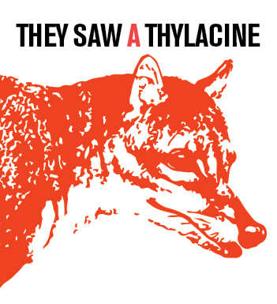

Thursday 5 May, 11am
Running time: 60 minutes, no interval
Followed by Q&A with the cast

Suitable for ages 14+
Warnings: contains coarse language

Find out more
[link to Thylacine full page]


Thursday 30 June, 10am & 1pm
Friday 1 July, 10am

Running time: TBC
Suitable for ages 4+

Find out more
[link to Picasso full page]

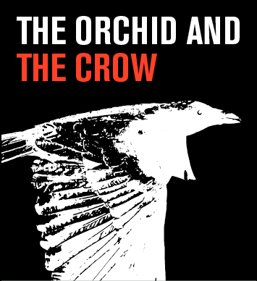
Thursday 15 September, 11am
Running time: 90 minutes no interval
Suitable for ages 14+

Warnings: Coarse language, adult themes, haze machine.

Find out more
[link to Orchid & Crow full page]


There are no weekday matinees for At the Hip, however school groups are able to purchase tickets to any of the Thursday* evening or Saturday matinee performances at the usual schools price.

Thursday 10 & 17 November, 8pm
Saturday 12 & 19 November, 3pm

Running time: TBC
Warnings: TBC
[link to At the Hip full page]

*No school bookings available for opening night Thursday 3 November

