Information for an online sale item

- Initial item on the shop page thumbnail, item name , type and price??
Little Boxes Quilt Kit
$A109-50
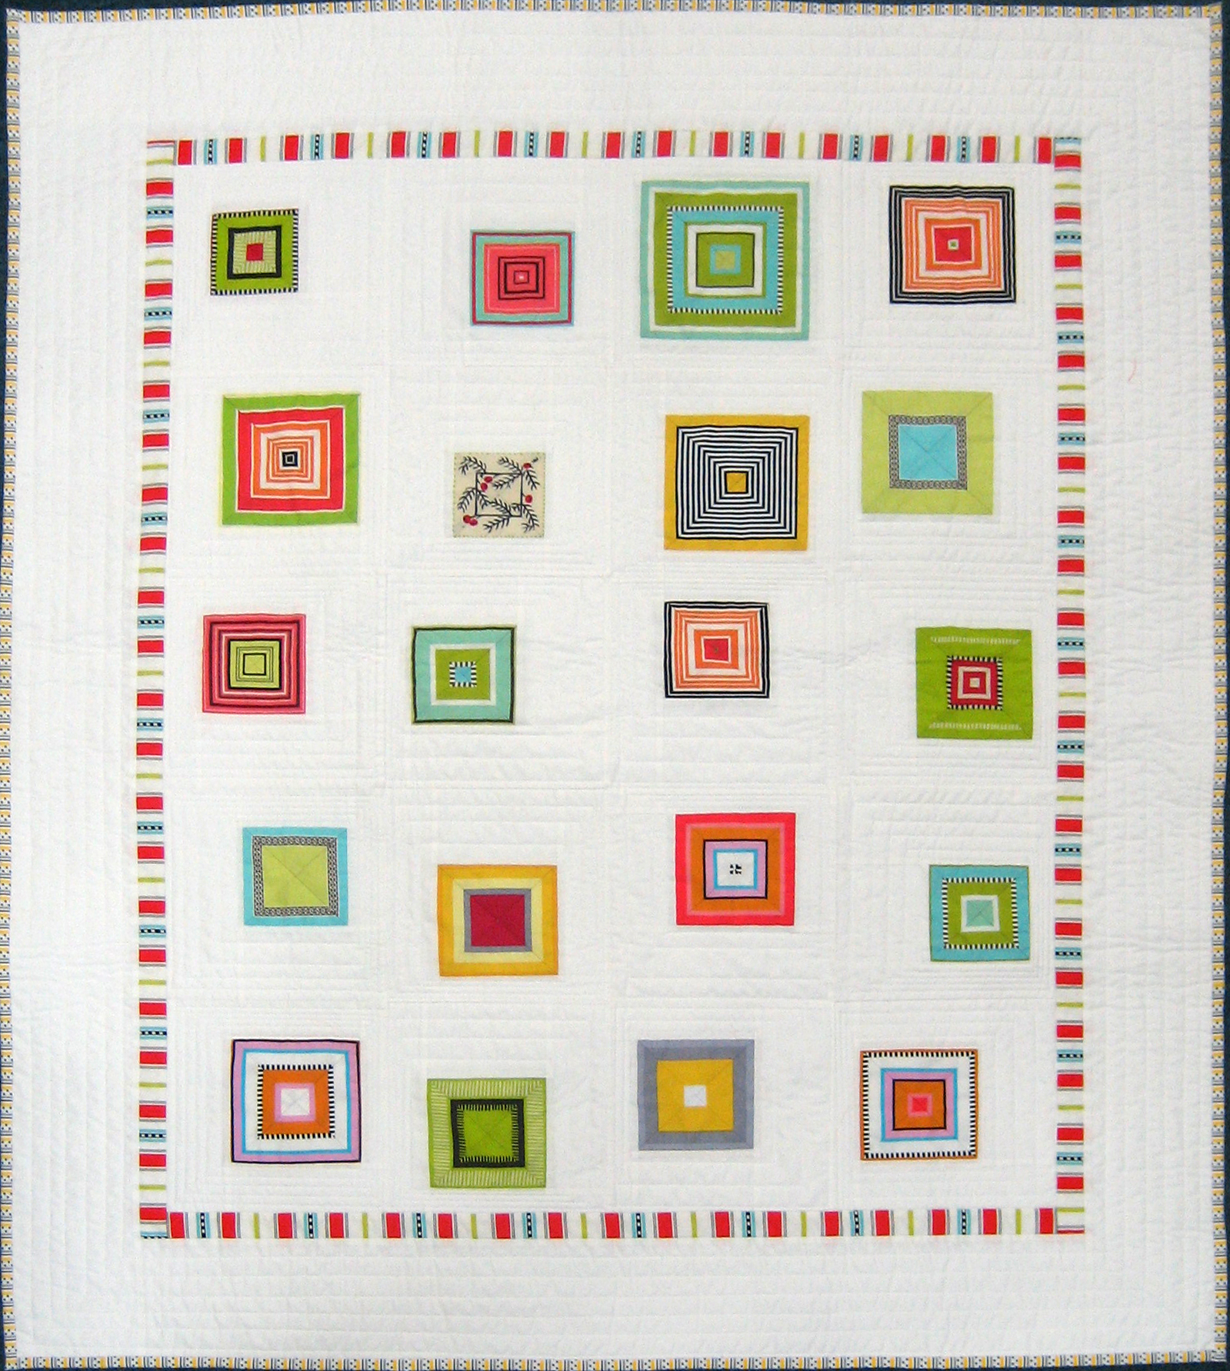

- Item Detail Page when clicked – larger image, description, price details and something about the item. One or two supporting images.. Ideally, the customer should be able to zoom into the detail of the quilt if necessary . maybe we need a hyperlink from the postage word to explain the costs. We would also need all the go to shopping bag etc links
Little Boxes Quilt Kit
$A109 plus postage
Size: 114 x 136cm
Kits Remaining: 3

This is a wonderful small cot or lap quilt. We love the simple design from Wendy Williams and Kerry, our Quilter In Residence, has selected an eclectic range of our store fabrics to make a striking and appealing quilt. It is both easy to piece and quilt.
The Kit